CHAPTER:01 INTRODUCTION

1.1 ABOUT PROJECT

E-Voting system is the system that aims in reducing the complexity and cost of the election process. Here the voter can vote in spite of his absence in the particular locality. The administrator’s effort is much reduced by checking the election status of all the localities individually forms a place and it is easy for him to announce the election result. The administrator is the soul controller of the E-Voting system in all process including refreshing the votes, editing the voter details, creating new nominee and so on. Thus the E-Voting system can reduce the cost and effort of election process. In this voting system each voter will be provided with a specific voter-id and a password through which access for the voting can be granted. If once the access is granted for a voter-id, then the access is denied for logging in till the voting system is refreshed for the next election. Similarly, the administrator will be provided with a special id through which he can view the status of the election. Based on the id segregation between the voter and administrator is carried out initially.

1.2 SCOPE OF THE PROJECT

The main goal of this project is to address the challenges of traditional voting methods by implementing a secure, efficient, and transparent E-Voting System. This system will streamline the voting process, ensuring integrity and accessibility while leveraging technology to minimize errors and fraud. The application will allow registered voters to securely cast their votes online, and all voting data will be stored in a database for real-time result computation.
Apart from that, an automated result calculation feature is integrated, displaying the vote count for each candidate. The system also includes admin controls to manage elections, candidates, and voter approvals, ensuring a smooth and secure election process.
The Followings Are The Project Scopes:

- The targeted users of the E-Voting system are eligible voters and administrators managing elections. And system prevents multiple voting, ensuring that each voter can only cast one vote per election.

- The system ensures secure authentication, allowing only approved voters to participate.

- A real-time vote-counting mechanism provides instant election results without requiring manual calculation.

- The candidate and election management modules allow the admin to add, update, and delete election details and candidates dynamically.

- The system requires an internet connection to update the voting database in real time.

- This E-Voting System will improve the transparency and efficiency of the voting process while ensuring security, accuracy, and ease of use for both voters and election administrators. The application is designed to be web-based, making it accessible from various devices.

NEED OF THE PROJECT

The Following Are The Key Needs Of The System:
- To provide a secure and transparent voting process.:
The system ensures that only registered and approved voters can participate, preventing fraudulent voting.

- To eliminate manual errors in vote counting.:
An automated system reduces human intervention, ensuring accuracy in tallying votes.

- To allow easy accessibility for all voters.:
Users can vote online from any location, eliminating the need for physical polling stations.

- To prevent multiple voting.:
The system enforces a one-vote-per-user policy, ensuring fair elections.

- To generate instant and accurate results.:
The vote count is updated in real-time, eliminating delays in result announcements.

- To reduce election costs and paperwork.:
By digitizing the voting process, the system minimizes the need for physical ballots, reducing costs and environmental impact.

CHAPTER:02
PROPOSED SYSTEM

PROPOSED SYSTEM
- The E-Voting System is a software application which avoids more manual hours that need to spend in record keeping and calculating votes.

- Through this the users and the candidates are registered online. Their information is stored in the database the admin can easily access the details of the voters and the candidates.

- The voters are allowed to vote online they can even vote by sitting at home. Every User allowed to vote only once so there is no chance of duplicated votes.

- This application keeps the data in a centralized way which is available to all the users simultaneously. It is very easy to manage historical data in database.

- They can easily use the tool that decreases manual hours spending for normal things and hence increases the performance

2.1 EXISTING SYSTEM

- Existing system is a manual one in which users and the details of the candidates are stored in books.

- The users have to wait a long time in queues for voting. Wrong and unwanted votes are given. Counting of votes are done manually which takes lots of time and inaccurate counting is done. It is very difficult to maintain historical data.

- In the existing system, there is compulsory need in physical presence in the time of election polling or vote counting

LIMITATIONS

- Traditional voting systems often require manual processes, leading to delay in vote counting and result declaration.

- Physical voting location can be inconvenient or inaccessible for some voters, reducing participation rates.

- Paper ballots are susceptible to errors, such as miscounting or accidental invalidation of votes.

- Manual system lack transparency and are more vulnerable to fraud, such as ballot stuffing or tampering.

- High operational costs, including printing ballots and staffing polling stations, make traditional voting systems inefficient.

2.2 OBJECTIVES

The primary objective of the E-Voting System is to provide a secure, transparent, and efficient platform for conducting elections. This system aims to replace the traditional voting process with an automated solution that minimizes errors, prevents fraud, and ensures quick result generation.

The Following Are The Key Objectives Of The System:

- To provide a secure and reliable voting platform:
The system ensures that only registered and approved voters can cast their votes, preventing unauthorized access and election fraud.

- To ensure a user-friendly and accessible voting process:
The system is designed to be simple and easy to use, allowing voters to participate from anywhere using an online platform.

- To eliminate manual vote counting errors:
By automating the vote-counting process, the system reduces human errors and ensures accurate results.

- To prevent multiple voting and ensure fairness:
Each voter can cast only one vote per election, ensuring that the results are fair and tamper-proof.

- To enable real-time vote counting and result generation:
The system automatically updates and displays election results as votes are cast, eliminating delays.

- To reduce election costs and paperwork:
Digital voting eliminates the need for physical ballots and manual data entry, making the election process cost-effective and environmentally friendly.

- To enhance transparency and trust in the voting process:
All votes are securely stored in a centralized database, preventing manipulation and ensuring a transparent election process.

2.3 SOFTWARE REQUIREMENT SPECIFICATION

ABOUT JAVA :

Java is an object-oriented programming language developed by James Gosling and Colleagues at Sun Microsystem in early 1990s. Unlike conventional languages which are generally designed either to be compiled to native code, or to be interrupted from source code at runtime, Java is intended to be compiled to a byte code, which is then run (generally using JIT compilation)

Java was started as a project called “oak” by James Gosling in June 1991. Gosling goals were to implemented a virtual machine and a language that had a familiar C-like notation but with greater uniformly and simplicity then C and C++. The first public implementation was Java 1.0 in 1995. It made the promise of “Write Once, Run Anywhere”, with free runtimes on popular platforms. It was fairly secure and its security was configurable, allowing for network and access to be limited. The major web browsers soon incorporated it into their standard configuration in secure “Applet” configuration popular quickly. New versions for large and small platforms (J2EE and J2ME) soon were designed with the advent of “Java 2”. Sun has not announced any plans for a “Java 3”.

ABOUT NETBEANS :

NetBeans IDE is a free, open source, integrated development environment (IDE) that enables you to develop desktop, mobile and web applications. The IDE supports application development in various languages, including Java, HTML5, PHP and C++. The IDE provides integrated support for the complete development cycle, from project creation through debugging, profiling and deployment. The IDE runs on Windows, Linux, Mac OS X, and other UNIX-based systems.
The IDE provides comprehensive support for JDK 7 technologies and the most recent Java enhancements. It is the first IDE that provides support for JDK 7, Java EE 7, and JavaFX 2. The IDE fully supports Java EE using the latest standards for Java, XML, Web services, and SQL and fully supports the Glassfish Server, the reference implementation of Java EE.

ABOUT DATABASE :

What Is Database ? :

A database is a separate application that stores a collection of data. Each database has one or more distinct Application for creating, accessing managing, searching and replicating the data it holds.
Other kinds of data stores can be used such as files on the file system or large hash tables in memory but data fetching and writing would not be fast and easy with those types of systems.
So now a day we use relational database management systems (RDBMS) TO store and manage huge volume of data. This is called relational database because all the data is stored into different bales and relations are established using primary keys or other keys known as foreign keys.

JDBC :

Java DB is Oracle’s supported distribution of the open source Apache Derby database. Its ease of use, standards compliance, full feature set, and small footprint make it the ideal database for Java developers. Java DB is written in the Java programming language, providing “write once, run anywhere” portability. It can be embedded in Java applications, requiring zero administration by the developer or user. It can also be used in client server mode. Java DB is fully transactional and provides a standard SQL interface as well as JDBC 4.1 compliant driver.

CHAPTER:03
SYSTEM DIAGRAM

3.1 DATA FLOW DAIGRAM ( DFD )

A Data Flow Diagram (DFD) is a traditional visual representation of the information flows within a system. A neat and clear DFD can depict the right amount of the system requirement graphically. It can be manual, automated, or a combination of both.
It shows how data enters and leaves the system, what changes the information, and where data is stored. The objective of a DFD is to showthe scope and boundaries of a system as a whole. It may be used as a communication tool between a system analyst and any person who plays a part in the order that acts as a starting point for redesigning a system. The DFD is also called as a data flow graph or bubble chart.

The following observations about DFDs are essential:
- All names should be unique. This makes it easier to refer to elements in the DFD.

- Remember that DFD is not a flow chart. Arrows is a flow chart thatrepresents the order of events; arrows in DFD represents flowing data. A DFD does not involve any order of events.

- Suppress logical decisions. If we ever have the urge to draw a diamond-shaped box in a DFD, suppress that urge! A diamond- shaped box is used in flow charts to represents decision points withmultiple exists paths of which the only one is taken. This implies an ordering of events, which makes no sense in a DFD.

- Do not become bogged down with details. Defer error conditions and error handling until the end of the analysis.

Standard Symbols For DFDs Are Derived From The Electric Circuit Diagram analysis And Are Shown In Fig:
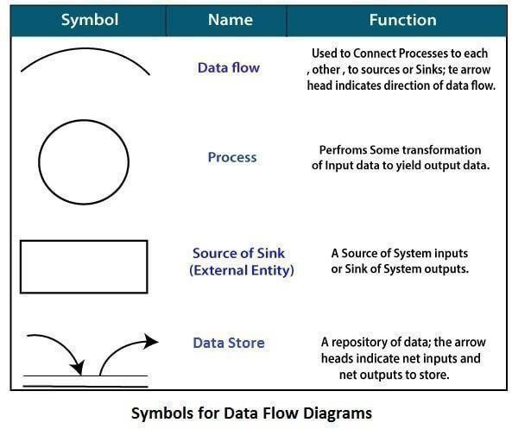

Circle: A circle (bubble) shows a process that transforms data inputs into data outputs.
Data Flow: A curved line shows the flow of data into or out of a process or data store.
Data Store: A set of parallel lines shows a place for the collection of data items. A data store indicates that the data is stored which can be used at a later stage or by the other processes in a different order. The data store can have an element or group of elements.
Source or Sink: Source or Sink is an external entity and acts as asource of system inputs or sink of system outputs

Level 0 :

Request

Response

E- Voting
Request
View information
Voter
Admin

Level 1 :

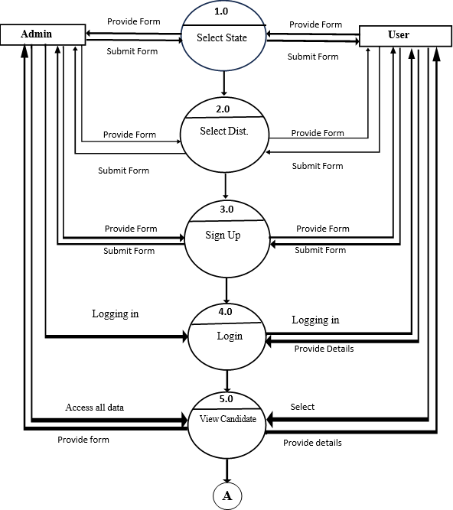
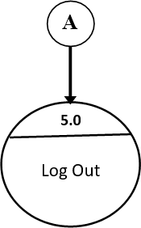

Level 2:

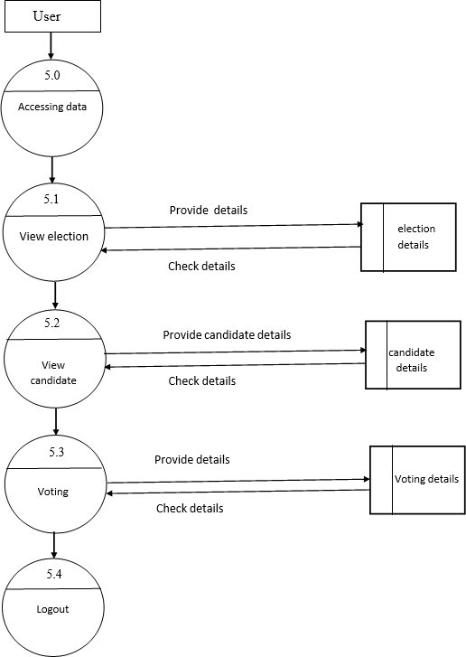

3.2 ENTITY RELATIONSHIP DAIGRAM (ERD)

The Entity-Relationship (ER) model was originally proposed by Peter in 1976 [Chen76] as a way to unify the network and relational database views. Simply stated the ER model is a conceptual data model that views the real world as entities and relationships. A basic component of the model is the Entity-Relationship diagram which is used to visually represent data objects. Since Chen wrote his paper the model has been extended and today it is commonly used for database design for the database designer, the utility of the ER model is:
It maps well to the relational model. The constructs used in the ER model can easily be transformed into relational tables.
It is simple and easy to understand with a minimum of training. Therefore, the model can be used by the database designer to communicate the design to the end user.
In addition, the model can be used as a design plan by the database developer to implement a data model in specific database management software.

ER Notation :
The symbols used for the basic ER constructs are:

Entities : are represented by labeled rectangles. The label is the name of the entity. Entity names should be singular nouns.

Relationships : are represented by a solid line connecting two entities. The name of the relationship is written above the line. Relationship names should be verbs

Attributes : when included, are listed inside the entity rectangle. Attributes which are identifiers are underlined. Attribute names should be singular nouns.

Cardinality : of many is represented by a line ending in a crow's foot. If the crow's foot is omitted, the cardinality is one.

Existence : is represented by placing a circle or a perpendicular bar on the line. Mandatory existence is shown by the bar (looks like a 1) next to the entity for an instance is required. Optional existence is shown by placing a circle next to the entity that is optional.
ER - DAIGRAM

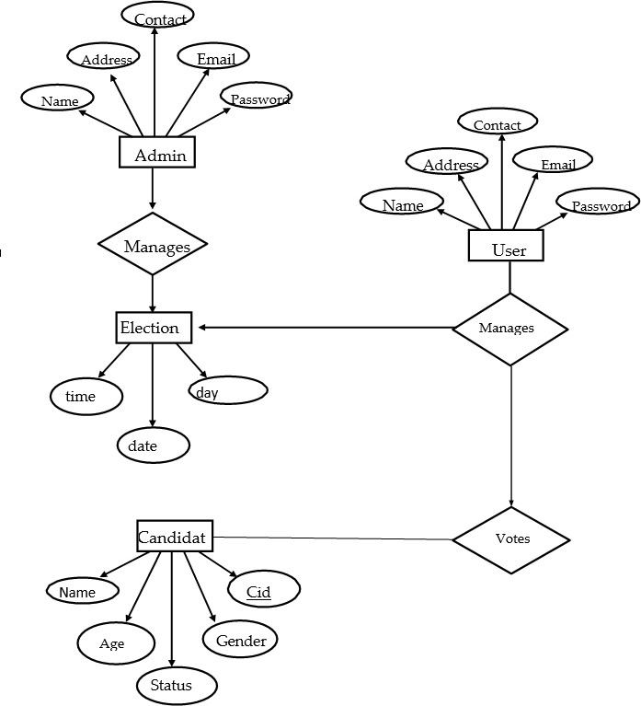
3.3 SYSTEM REQUIEMENT

HARDWARE REQUIEMENT :

- Windows 7.
- 2GB of RAM or Above.
- Minimum 20GB Hard-Disk.
- 1 Keyboard & 1 Mouse.
- Printer.

SOFTWARE REQUIREMENT :

- Operating System :
- Windows 7.

- Front-End Technology :
- HTML, CSS, JS.

- Back-End Technology :
- Java
- JAVA DB
- Glashfish Server 3.1

- Environment Used :
- JAVA( Netbeans IDE 8.2 )
- JDK 8.2

CHAPTER:04
SYSTEM DESIGN

4.1 DATABASE DESIGN

USER REGISTRATION :

Field | Datatype | Key Attribute | Description
Name | Varchar | Not null | It provides name for user
Gender | Varchar | Not null | It provides gender for user
DOB | Varchar | Not null | It provides DOB for user
Contact | Varchar | Not null | It provides Contact No for user
Address | Varchar | Not null | It provides Address for user
E-Mail | Varchar | Not null | It provides E-mail for user
Password | Varchar | Not null | It provides Password for user
Confirm Password | Varchar | Not null | It provides Confirm password for user

ADD ELECTION :

Field | Datatype | Key Attribute | Description
Election_ID | Varchar | Not null | It provides Election_ID for Candidates
Election_Name | Varchar | Not null | It provides Election_Name for Candidates
Election_Date | Varchar | Not null | It provides Election_Date for Candidates
Code_Of_Conduct_Date | Varchar | Not null | It provides Code_Of_Conduct _Date for Candidates

ADD CANDIDATES :

Field | Datatype | Key Attribute | Description
ID | Varchar | Not null | It provides ID for Candidates
Election_Type | Varchar | Not null | It provides Election_Type for Candidates
Candidate_Name | Varchar | Not null | It provides Candidate_Name for Candidates
Candidate_Pic | Varchar | Not null | It provides Candidate_Pic for Candidates
Party_Name | Varchar | Not null | It provides Party_Name for Candidates
Party_Pic | Varchar | Not null | It provides Party_Pic for Candidates
Address | Varchar | Not null | It provides Candidate address for Candidates
Phone_No | Varchar | Not null | It provides Phone_No for Candidates
Total_Votes | Varchar | Not null | It provides Total_Votes All

VOTES :

Field | Datatype | Key Attribute | Description
E-Mail | Varchar | Not null | It stores Voters E-Mail
Election_Type | Varchar | Not null | It stores Election_Type of each vote

4.2 INPUT DESIGN
INDEX :

<%@page contentType="text/html" pageEncoding="UTF-8"%>
<!DOCTYPE html>
<html>
<head>
<meta http-equiv="Content-Type" content="text/html; charset=UTF-8">
<title>E-Voting!!</title>
<style>
*{
margin: 0%;
padding: 0%;
box-sizing: border-box;
font-family: 'Times New Roman', Times, serif;
}
body{
background-image: url(B1.jpg);
background-size: cover;
object-fit: cover;
background-position: center;
background-repeat: no-repeat;
height: 100vh;
margin: 0%;
}
nav{
color: #fff;
display: flex;
justify-content: space-between;
align-items: center;
padding: 1rem;
font-weight: bolder;
}
logo{
/*background-image: url(logo.png);
background-repeat: no-repeat;*/
font-size: 40px;
font-weight: bolder;
font-family: 'Courier New', Courier, monospace;
border: 5px solid rgb(112, 110, 110);
border-radius: 8px;
padding: 4px;
margin: 2px;
}
.nav-links{
list-style: none;
display: flex;
font-size: 20px;
}
.nav-links li{
margin-left: 20px;
border: 2px solid black;
padding: 10px 10px 10px 10px;
border-radius: 15px;
}
.nav-links li:hover{
background-color: green;
}
.nav-links a{
color: #fff;
text-decoration: none;
padding: 8px 16px;
border-radius: 15px;
transition: background-color 0.3s;
height: 20px;
width: 20px
}
transition: background-color 0.3s;
height: 20px;
width: 20px;
}
</style>
</head>
<body>
<nav>
<div class="logo">E-Voting</div>
<ul class="nav-links">
<li><a href="Home.jsp">GO</a></li>
</ul>
</nav>
</body>
</html>

USER_REGISTRATION_SERVLET. JAVA :

package Servlets;
import java.io.File;
import java.io.FileOutputStream;
import java.io.IOException;
import java.io.InputStream;
import java.sql.Connection;
import java.sql.DriverManager;
import java.sql.PreparedStatement;
import java.sql.SQLException;
import java.time.LocalDate;
import java.time.Period;
import javax.servlet.ServletException;
import javax.servlet.annotation.WebServlet;
import javax.servlet.http.HttpServlet;
import javax.servlet.http.HttpServletRequest;
import javax.servlet.http.HttpServletResponse;
import javax.servlet.http.Part;

@WebServlet("/User_Registration_Servlet")
public class User_Registration_Servlet extends HttpServlet {
private static final long serialVersionUID = 1L;

protected void doPost(HttpServletRequest request, HttpServletResponse response) throws ServletException, IOException {
response.setContentType("text/plain");

String fullName = request.getParameter("txt_fullname");
String gender = request.getParameter("txt_gender");
String dob = request.getParameter("dob");
String contact = request.getParameter("txt_contact");
String address = request.getParameter("txt_name");
String email = request.getParameter("txt_email");
String password = request.getParameter("txt_password");
String confirmPassword = request.getParameter("txt_cpassword");

if (!isUserAdult(dob)) {
response.getWriter().write("error-age");
return;
}
if (!password.equals(confirmPassword)) {
response.getWriter().write("error-password");
return;
}
Connection con = null;
PreparedStatement pst = null;
try {
Class.forName("org.apache.derby.jdbc.ClientDriver");
con = DriverManager.getConnection("jdbc:derby://localhost:1527/Users_Registration", "Users_Registration", "Users_Registration");

String query = "INSERT INTO Users_Registration (FULLNAME, GENDER, DOB, CONTACT, ADDRESS, EMAIL, PASSWORD, CONFIRM_PASSWORD, STATUS) VALUES (?, ?, ?, ?, ?, ?, ?, ?, 'Pending')";
pst = con.prepareStatement(query);
pst.setString(1, fullName);
pst.setString(2, gender);
pst.setString(3, dob);
pst.setString(4, contact);
pst.setString(5, address);
pst.setString(6, email);
pst.setString(7, password);
pst.setString(8, confirmPassword);

int rowsInserted = pst.executeUpdate();

if (rowsInserted > 0) {
response.getWriter().write("Registration successfully Completed !!..WAIT FOR ADMIN APPROVEL AND THEN LOGIN");
} else {
response.getWriter().write("error-db");
}

} catch (ClassNotFoundException | SQLException e) {
e.printStackTrace();
response.getWriter().write("error: " + e.getMessage());
} finally {
try {
if (pst != null) pst.close();
if (con != null) con.close();
} catch (SQLException ex) {
ex.printStackTrace();
}
}
}

private boolean isUserAdult(String dob) {
try {
LocalDate birthDate = LocalDate.parse(dob);
LocalDate currentDate = LocalDate.now();

int age = Period.between(birthDate, currentDate).getYears();
return age >= 18;
} catch (Exception e) {
return false;
}
}
}
4.3 OUTPUT DESIGN
INDEX :

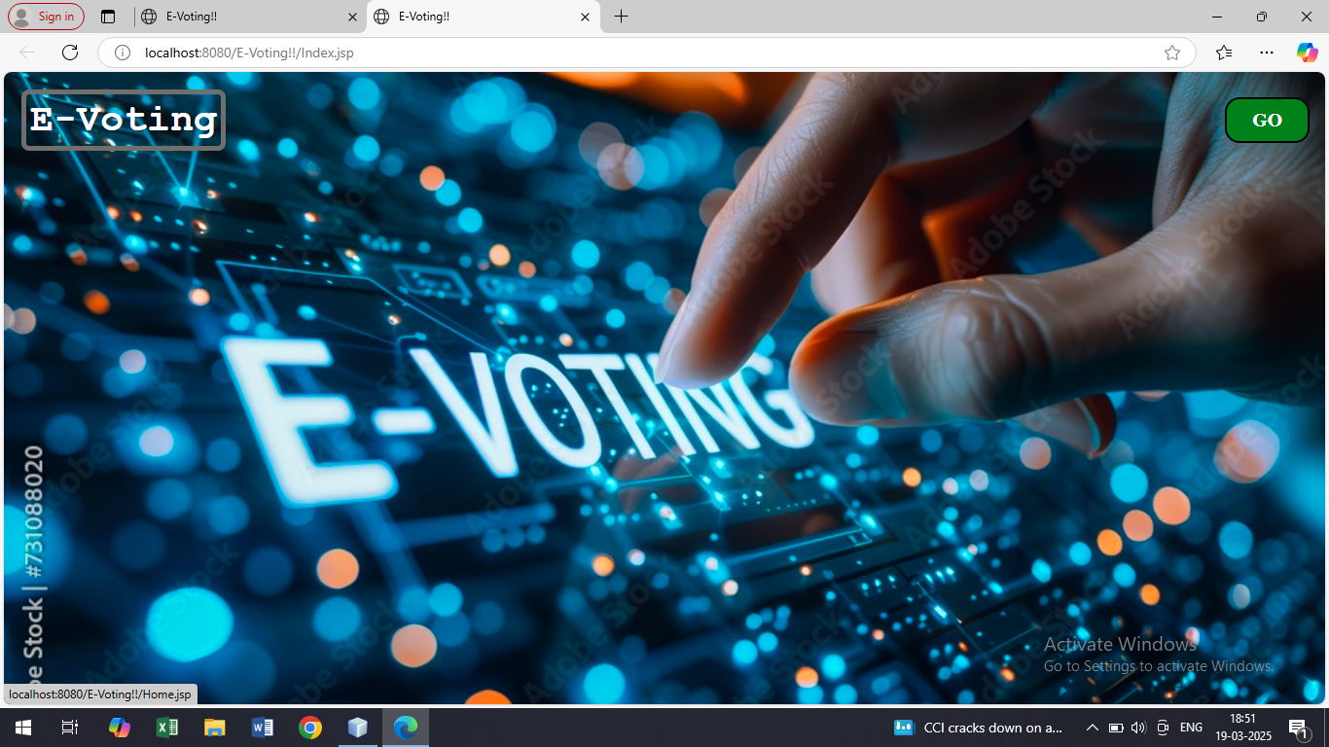
DASHBOARD :
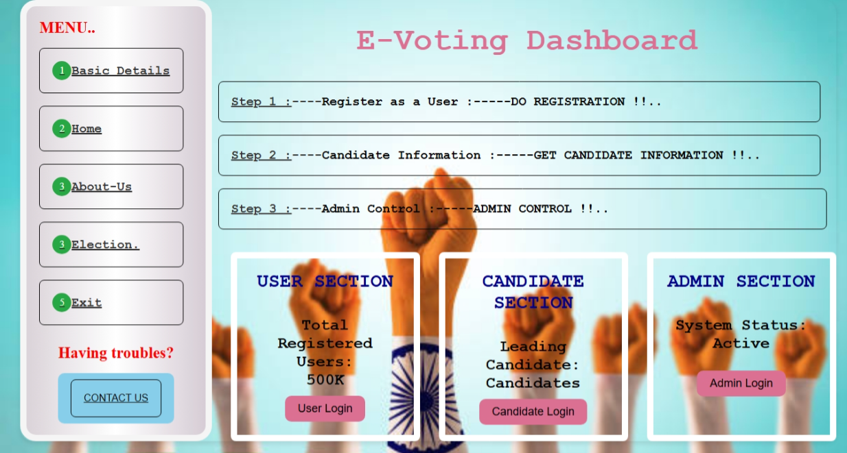
HOME :

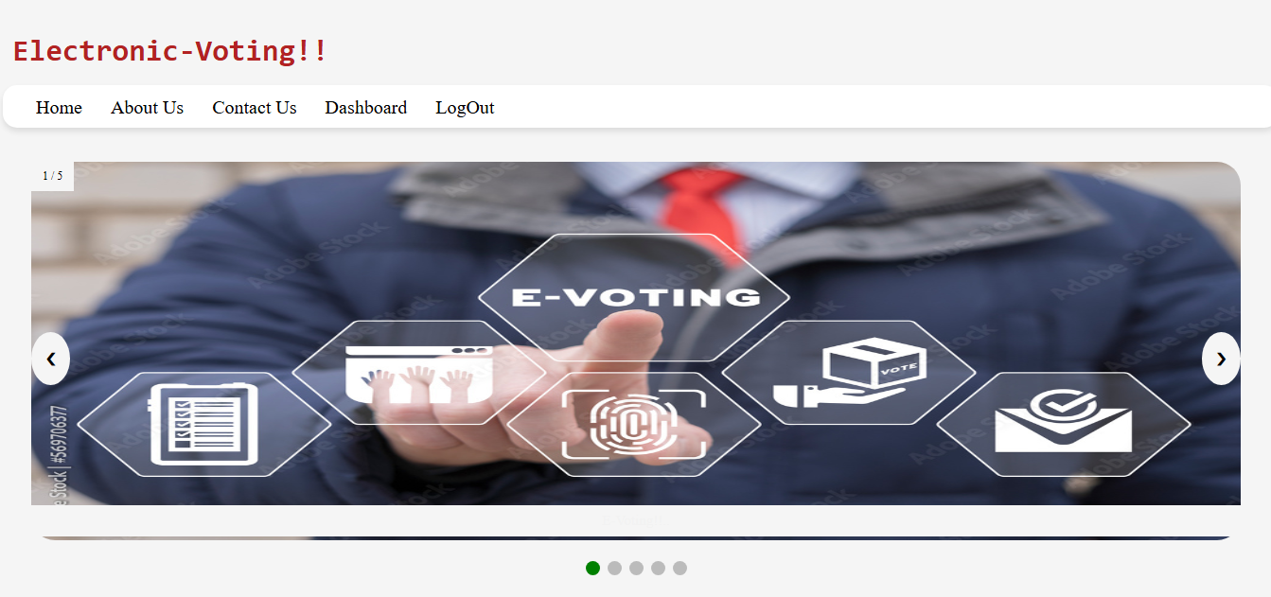
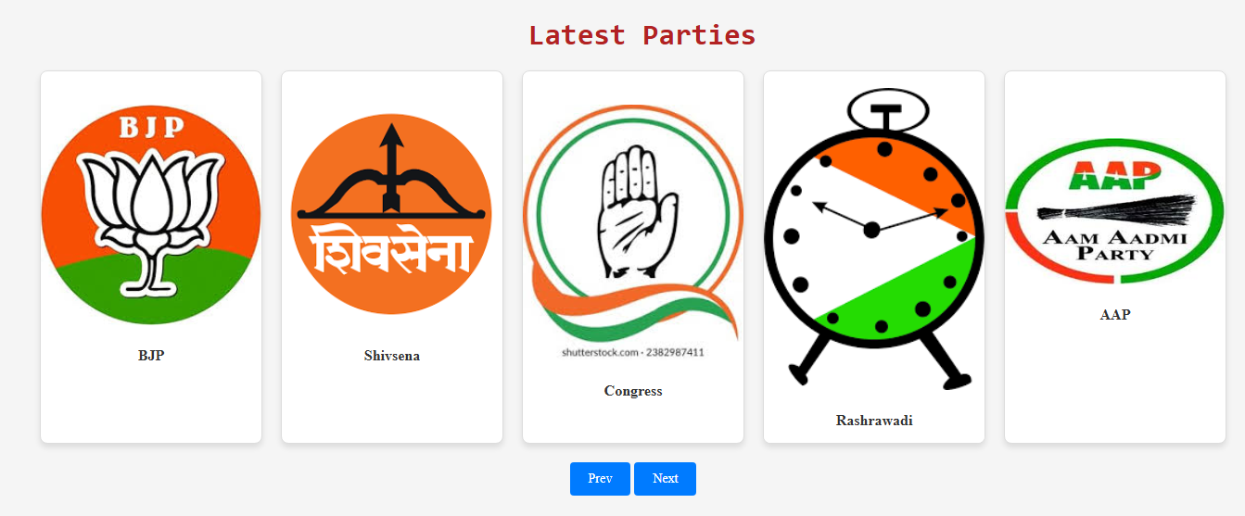
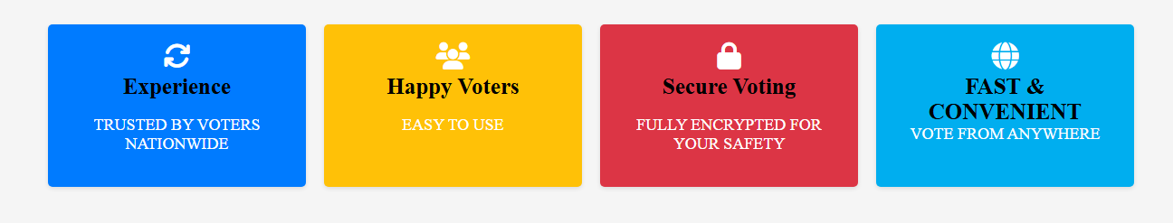

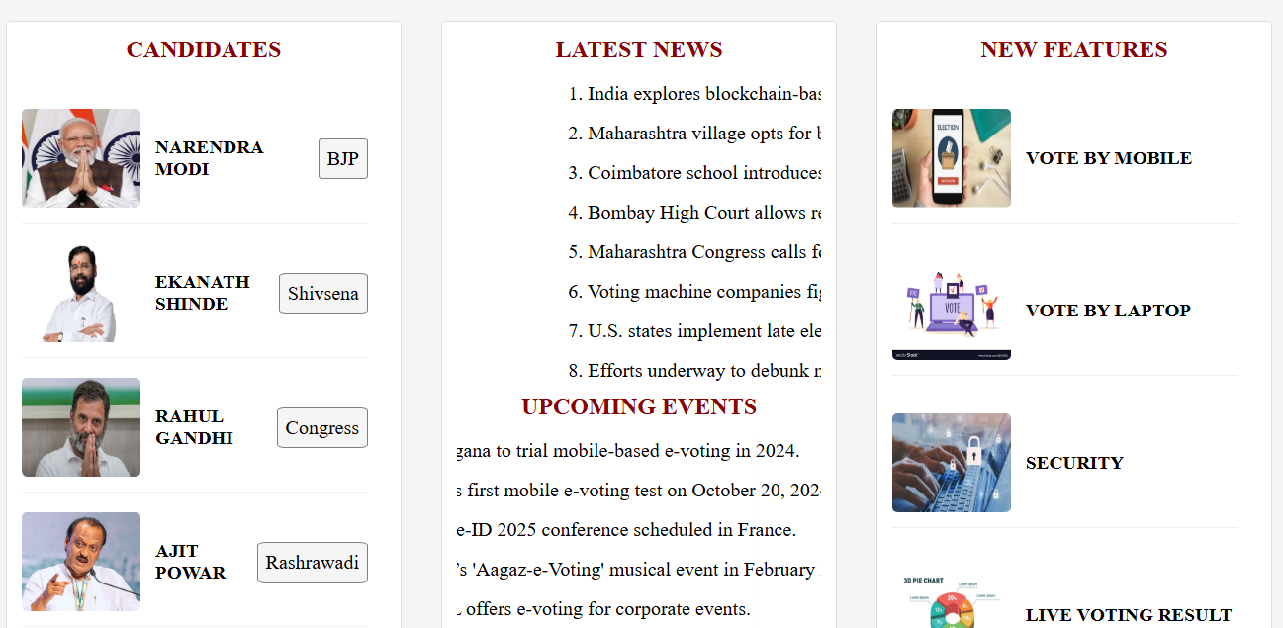
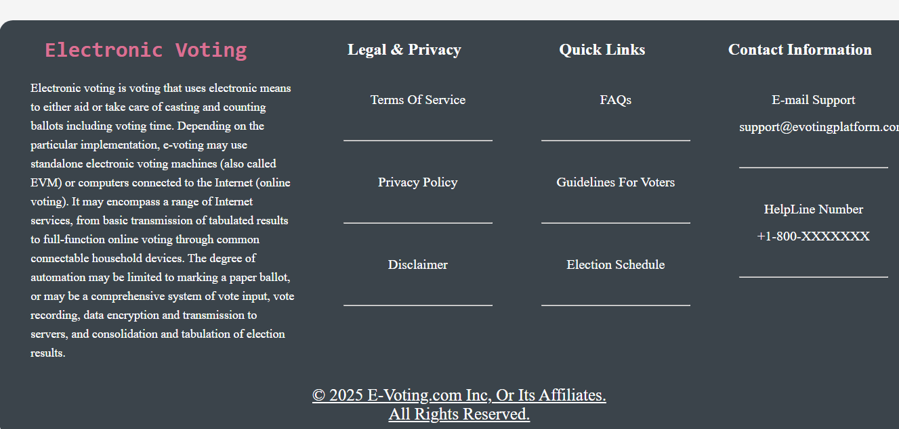

ABOUT :

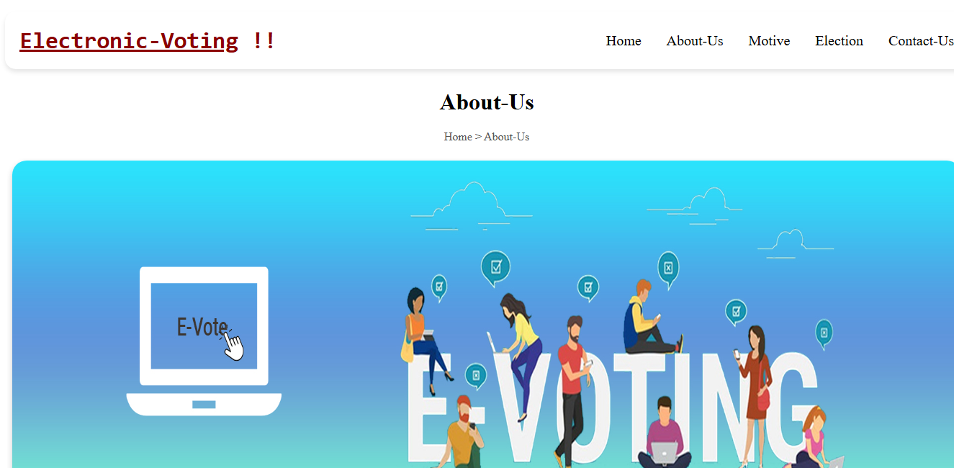
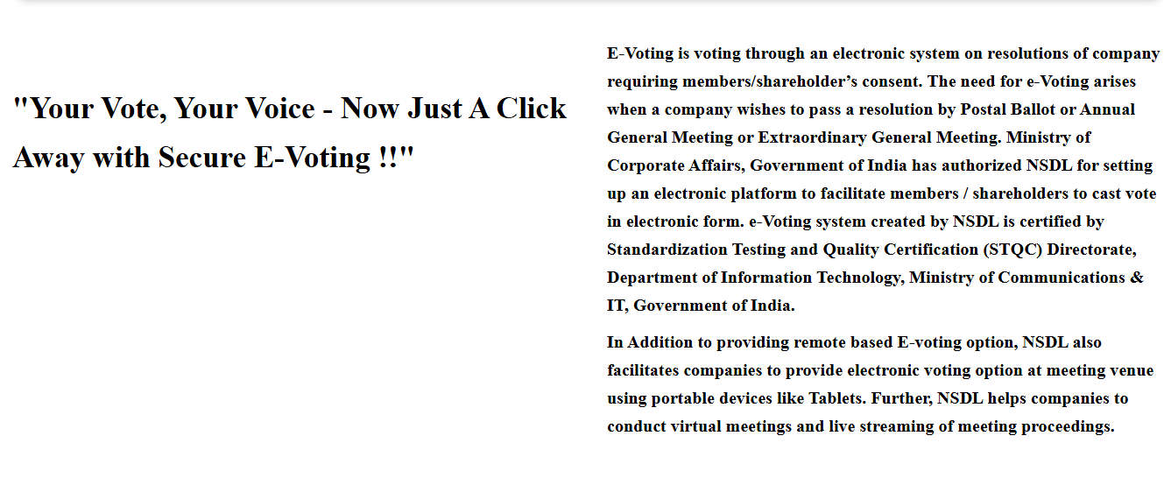
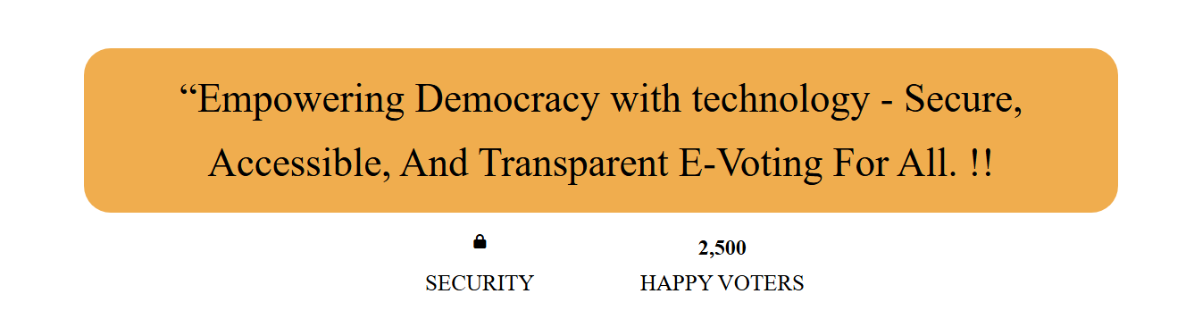
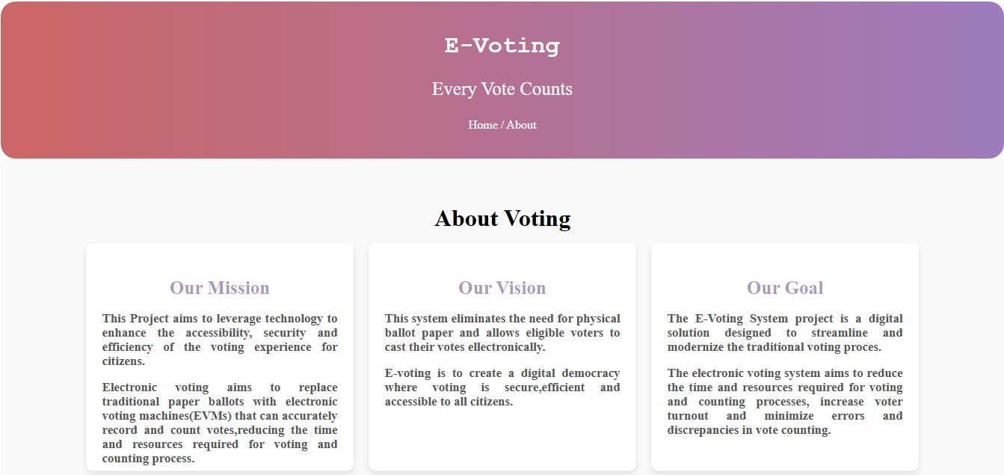

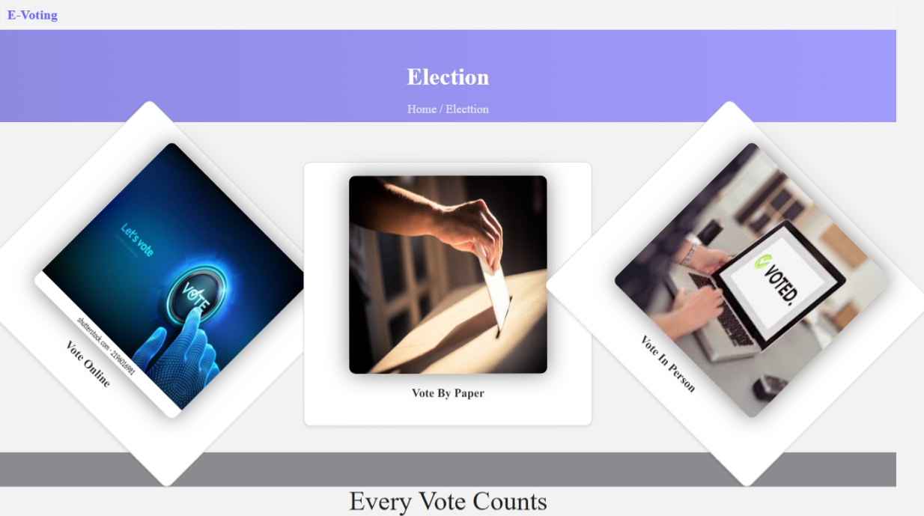

CONTACT :

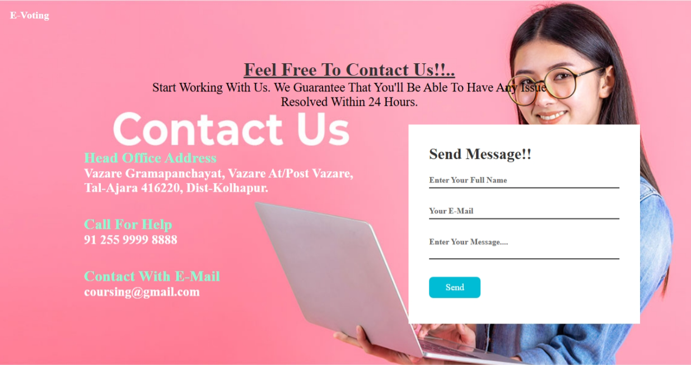

USER LOGIN :

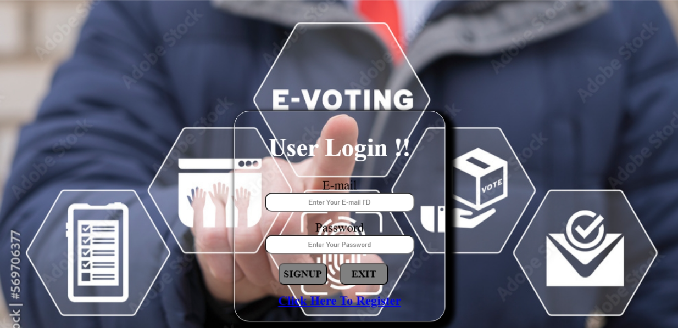

USER REGISTRATION :

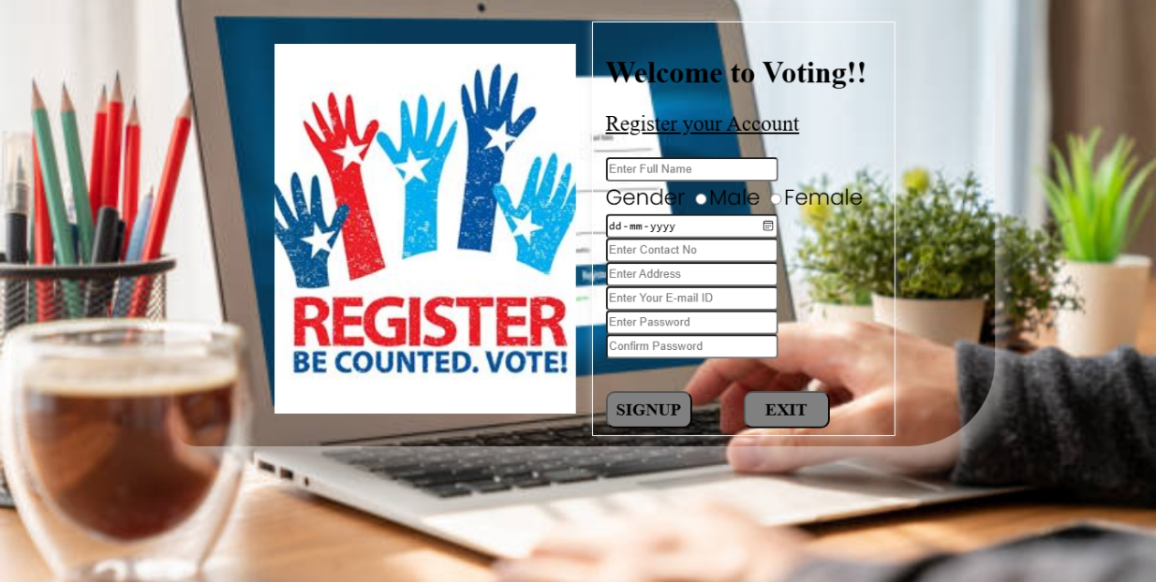

SELECT ELECTION :



VOTING PAGE :

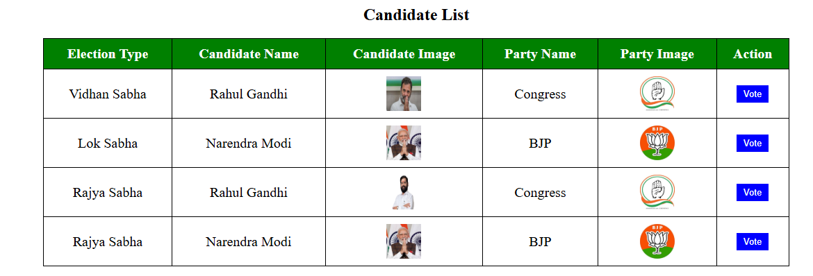

CANDIDATE LOGIN :

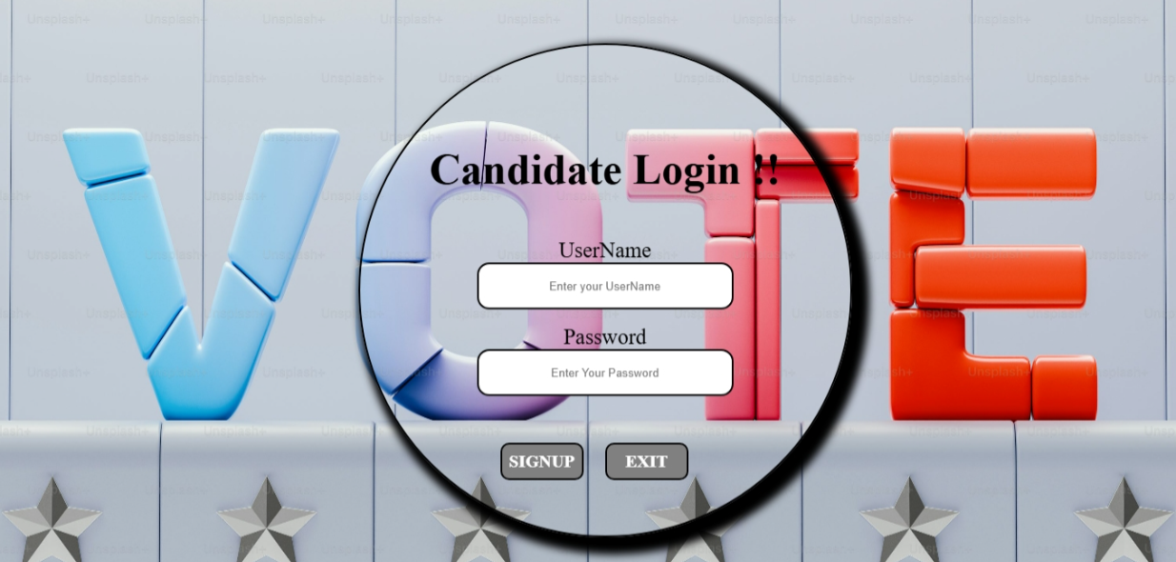

VIEW PARTY SYMBOL:

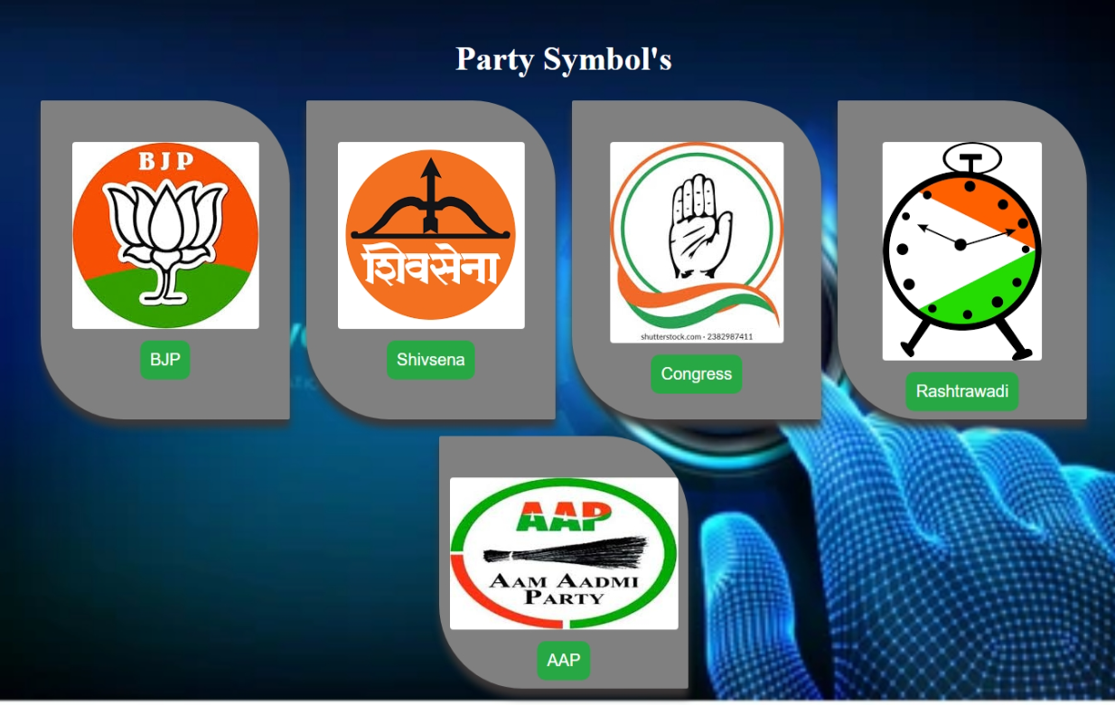

ADMIN LOGIN :

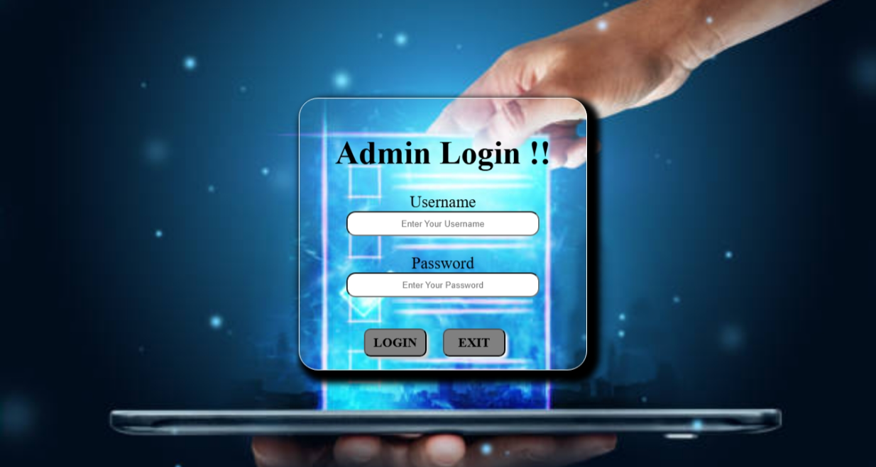

ADMIN PAGE :

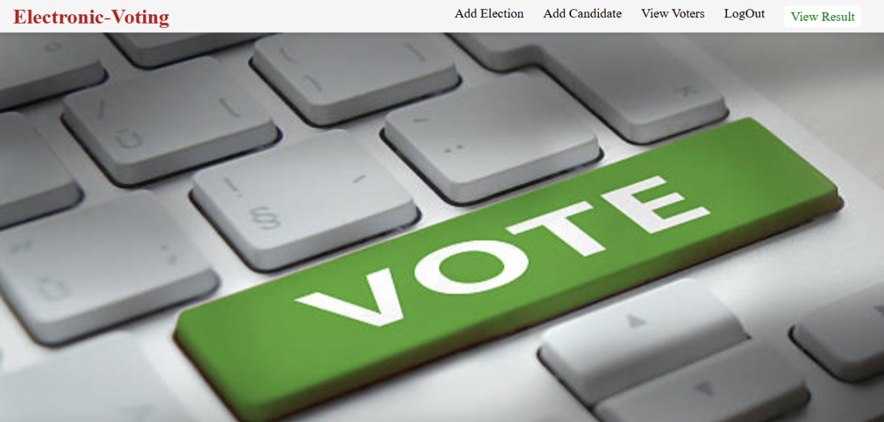

ADD ELECTION:

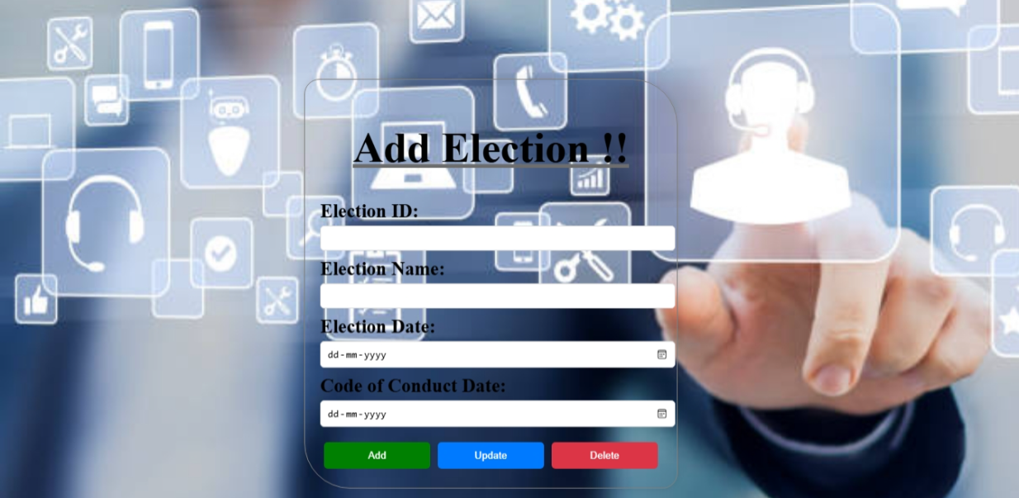

ADD CANDIDATES:

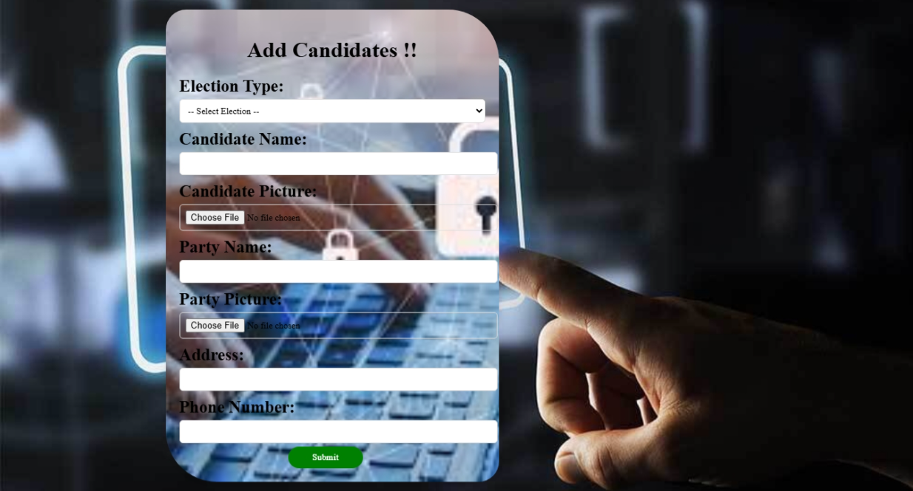

RESULT :


CHAPTER:05

USER MANUAL

5.1 SYSTEM DESIGN

THE PROCESS MODEL USED FOR THE SYSTEM:

The process model used for this system “Classic Life Cycle” as this is simple and is best for small scale project.
The “Classic Life Cycle” is also called System Development Life Cycle (SDLC). It is
defined “The growth of an information system is through various identifiable stages. These stages are grouped together and referred as SDLC.”
The structure of its stages which we used in our project is as follows:
Water-Fall Model:
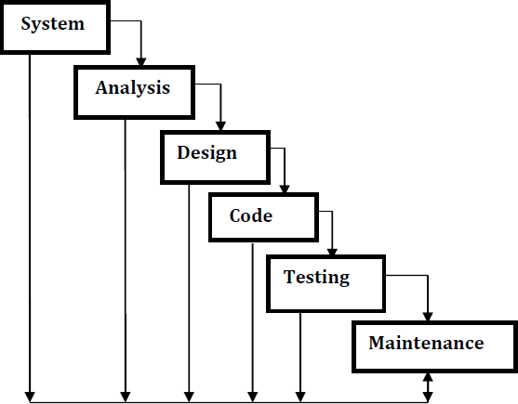

SYSTEM DESIGN

The system design for the E-Voting System ensures a secure, reliable, and scalable platform for conducting elections. The system is built to handle multiple users simultaneously while ensuring authentication, integrity, and transparency in the voting process.

It consists of two main interfaces:

1. Admin Panel – Manages elections, candidates, and voter approvals.

2. Voter Panel – Allows registered users to select an election, cast their vote, and view results.

The system uses Java DB (Derby) for data storage and follows a structured JSP and Servlet framework for efficient data processing and user interactions. Security measures, including one-time voting verification, are implemented to maintain election fairness.

SYSTEM FLOW

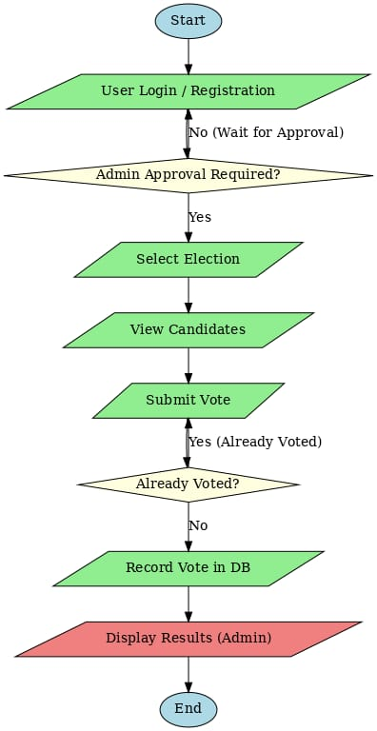

CHAPTER:06

OUTPUT SCREENS

USER REGISTRATION :

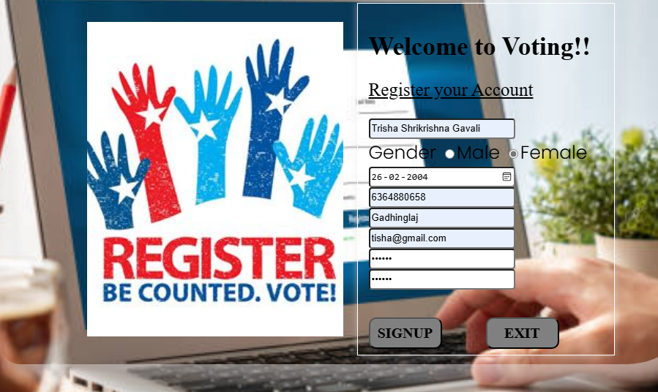

USER LOGIN :

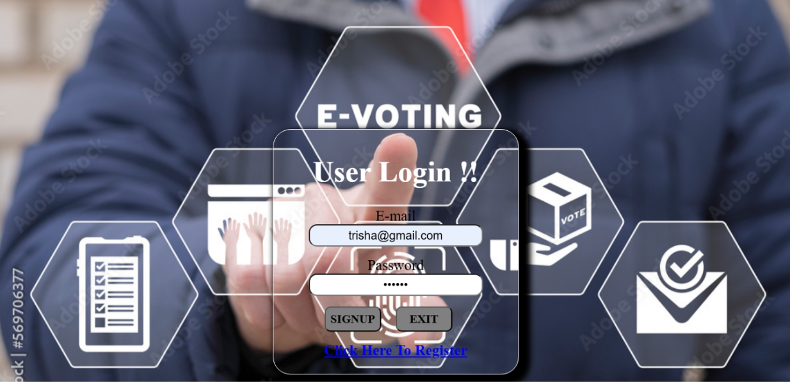

SELECT PARTICULAR ELECTON :
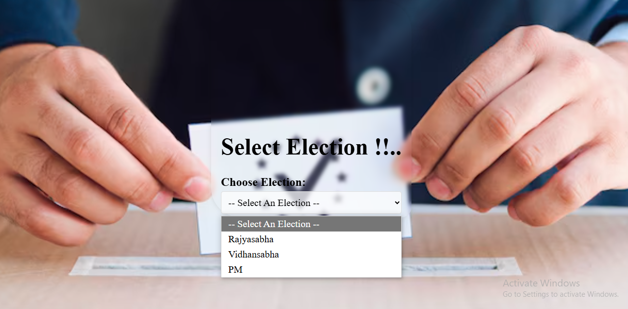

Adding Elections :

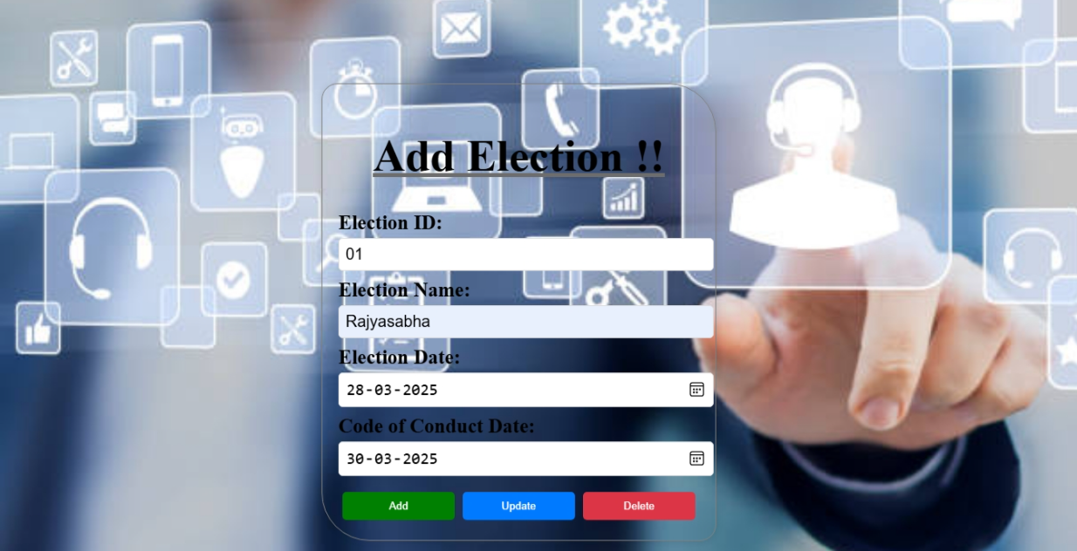

ADDING CANDIDATES :

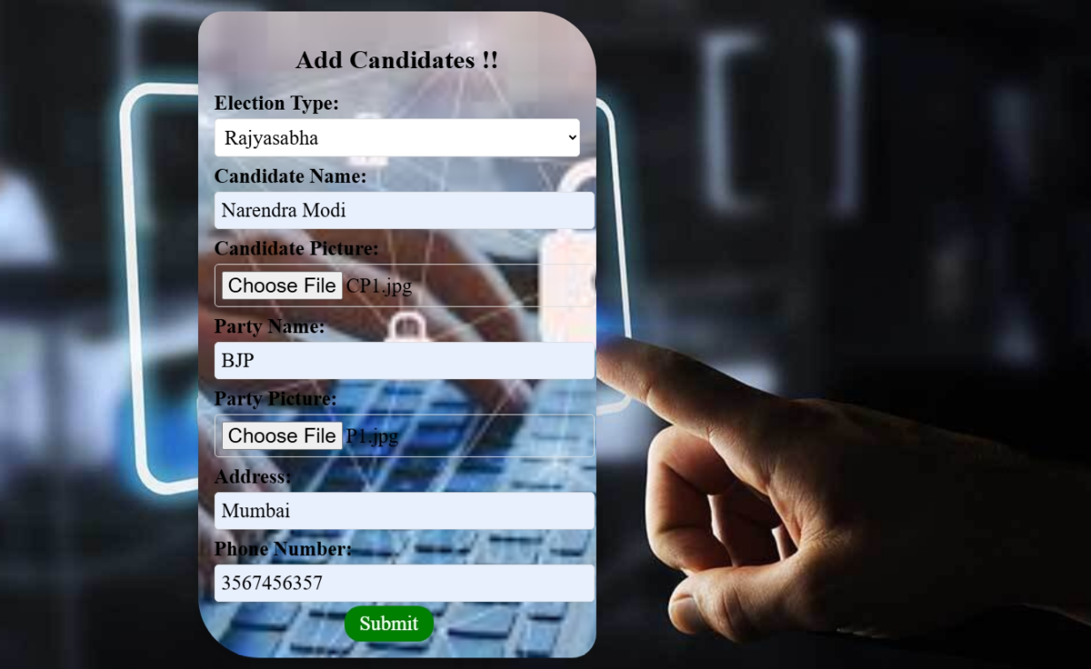

CHAPTER:07

REPORTS

USER REGISTER FOR VOTING :

The Pop-Up Msg

Waiting For Admin Approval For Login And Vote :

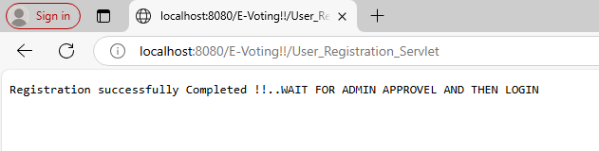

After Registration The User Data Goes To Pending Voter List :
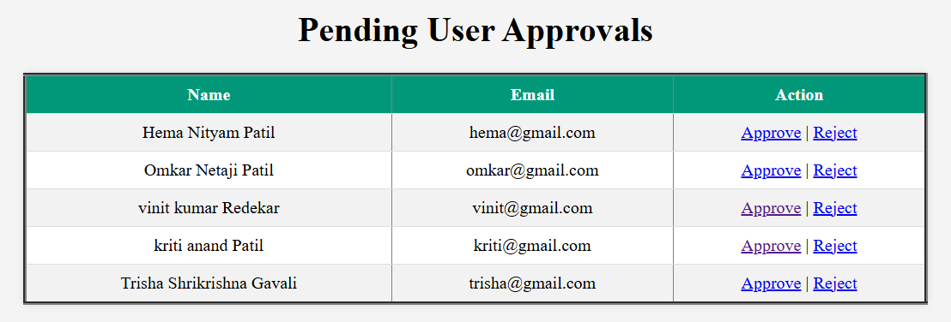
After Approval Of Admin User Data Replace The Place Pending Users To Approved / Registered Voters:

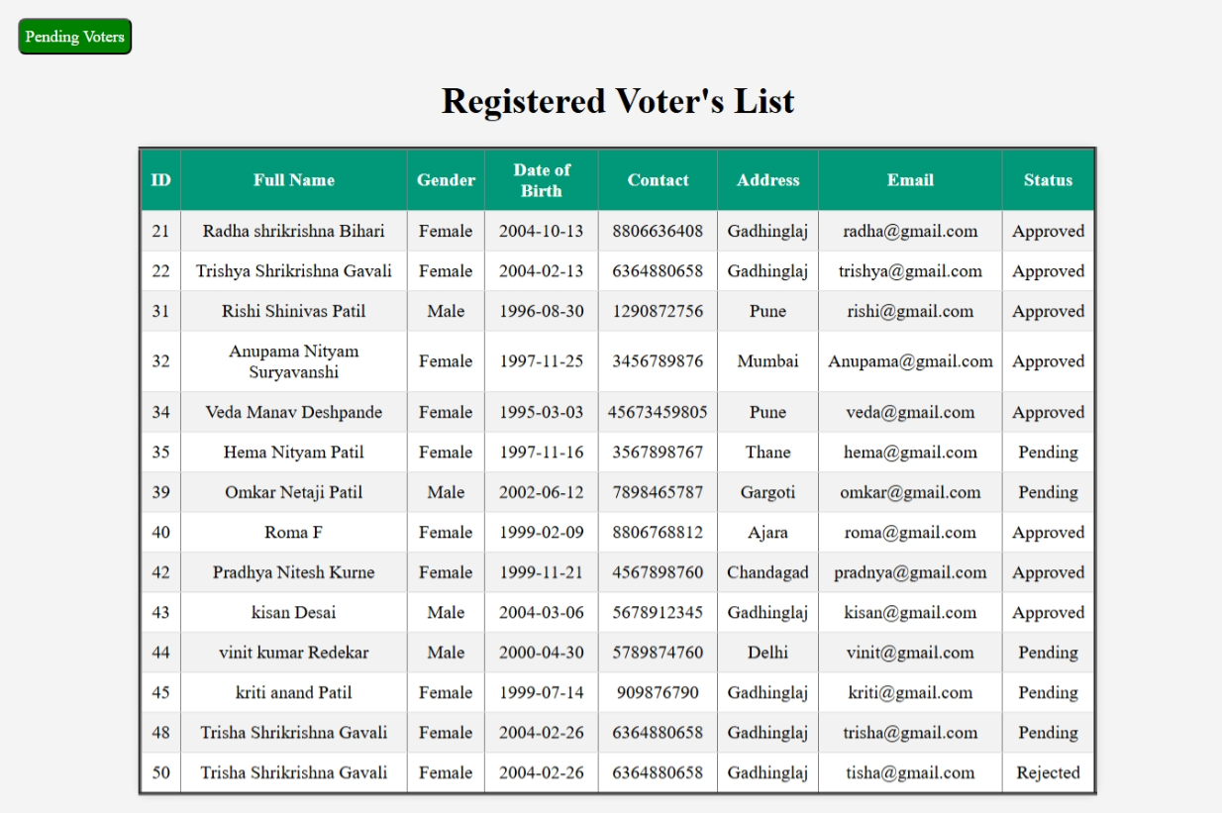

After Admin Approval User Can Log-In With Name And Password :
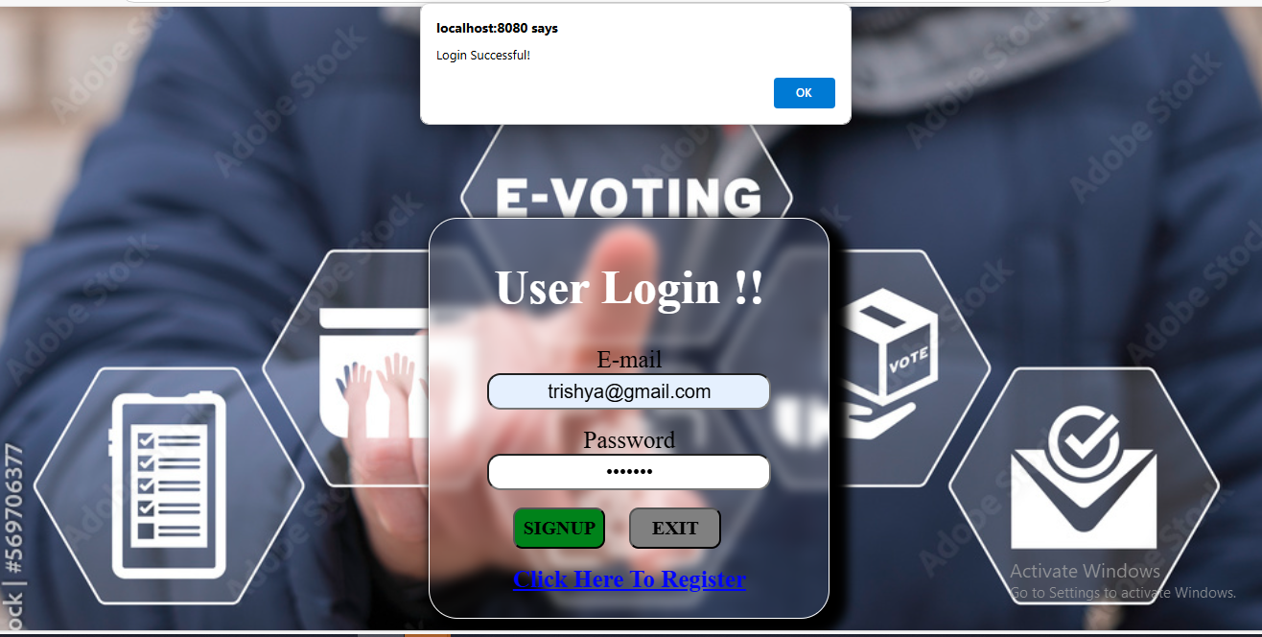

After Successfully Login, Login Page Redirects To Election Page. Where User / Voter Choose A Particular Election For Vote :


After Choosing A Election Of Dropdown List The Page Redirect To Voting Page And User Can Vote Now Using Vote Button :

Pop-Up Msg Afer Voted:
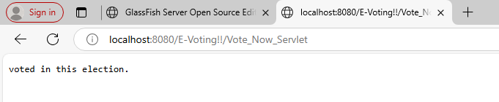

The Result Screen.. Click The dropdown List For Checking The Particular Election Result :

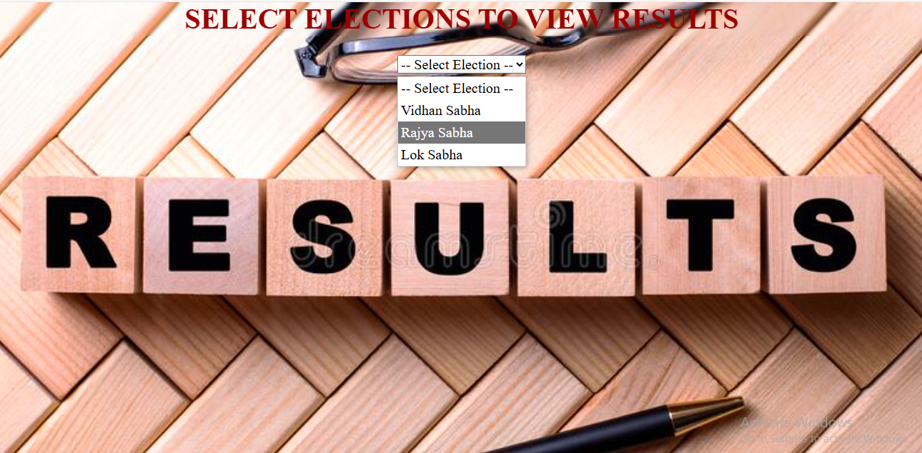

RESULT VIEW AS PER ELECTION:



CHAPTER:08

CONCLUSION

&

SUGGESTIONS

9.1 CONCLUSION
The software was designed in such a way that future changes can be done easily. The following conclusions can be deduced from the development of the project.

- Automation of the entire system improves the productivity.

- It provides a friendly graphical user interface which proves to be better when compared to the existing system.
- It gives appropriate access to the authorized users depending on their permissions.

- It effectively overcomes the delay in communications.
- Updating of information becomes so easier.
- System security, data security and reliability are the striking features.

- The System has adequate scope for modification in future if it is necessary.

SUGGESTIONS
The E-Voting System can be further improved by implementing the following enhancements:

- Enhanced Security Measures: Implementing Two-Factor Authentication (2FA) and data encryption for improved security.

- User Experience Improvements: Introducing real-time election results and a mobile-friendly interface for better accessibility.

- Advanced Admin Features: Implementing voter eligibility verification, role-based access control, and graphical result visualization.

- System Performance Optimization: Optimizing database indexing, using AJAX-based voting submission, and implementing load balancing.

- Blockchain-Based Voting (Future Consideration): Ensuring tamper-proof voting and immutable vote records using blockchain technology.
These enhancements will improve the security, transparency, and efficiency of the system while making it more user-friendly and scalable.

BIBLIOGRAPHY

BOOKS :--
- JAVA : Y. Daniel Liang, “: Introduction to java programing”.
- MySQL : Paul Dubois ,”MySQL”.
- JAVA DB : Marco Schulman, “Java Persistence with Derby”.
WEBSITES :--
- JAVA :-
- www.google.com
- www.javatpoint.com
- www.w3schoool.com

- MySQL :-
- https://www.mysql.com/
- http://www.mysqltutorial.org

- JDBC :-
- http://db.apache.org/derby/

